Testing Guide and Results
ResearchSkill v2 — how to test, and the tested result

1. Smoke test (about 1–3 minutes)
python run_evaluation.py --model qwen2.5:3b --limit 3 --mode all
Expected result
- Console prints === BASELINE ===, === SKILL ===, === V1 ===, === V2 ===
- Each configuration lists three lines such as Task 01 | 4.82s
- The four output files appear in results/

2. Single-configuration test
python run_evaluation.py --model qwen2.5:3b --limit 5 --mode v2

3. Full test
python run_evaluation.py --model qwen2.5:3b --mode all

4. Verify the output
python -c "import pandas as pd; print(pd.read_csv('results/summary.csv'))"
One row per configuration should appear with mean score, mean latency and risk flags.

5. Troubleshooting
Problem | Fix
ConnectionError to localhost:11434 | Start Ollama (ollama serve)
404 / model not found | Run ollama pull <model> and use the same name in --model
FileNotFoundError: results/raw_results.json | Run mkdir results
FileNotFoundError: skill/... or data/... | Run commands from the repository root
Request timeout | Use a smaller model or raise timeout in agent.py

6. Tested result
Screenshot of the evaluation run (local, Windows, Ollama):
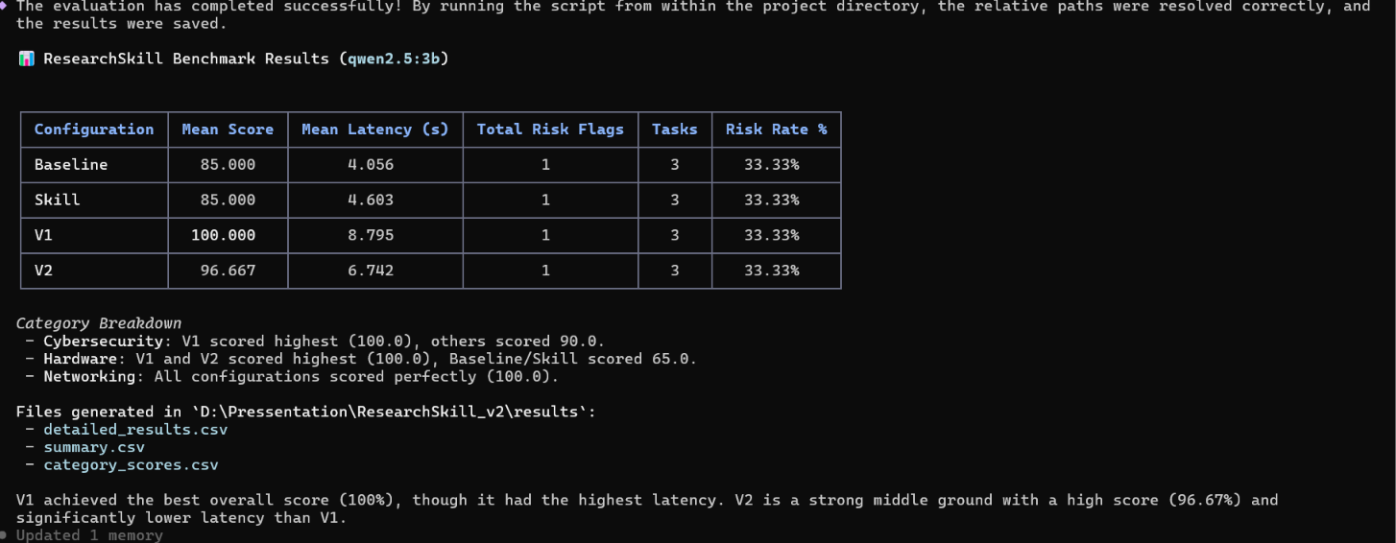

Measured summary
Model: qwen2.5:3b · Run: smoke test (--limit 3 --mode all, 3 tasks per configuration)
Configuration | Mean score | Mean latency (s) | Risk flags | Tasks | Risk rate
Baseline | 85.000 | 4.056 | 1 | 3 | 33.33%
Skill | 85.000 | 4.603 | 1 | 3 | 33.33%
Skill V1 | 100.000 | 8.795 | 1 | 3 | 33.33%
Skill V2 | 96.667 | 6.742 | 1 | 3 | 33.33%

Category breakdown
- Cybersecurity: V1 scored highest (100.0); the others scored 90.0.
- Hardware: V1 and V2 scored 100.0; Baseline and Skill scored 65.0.
- Networking: all configurations scored 100.0.

Observations
- V1 achieved the best score but had the highest latency (about 2.2x baseline).
- V2 scored close to V1 (96.67) with lower latency (6.74 s vs 8.80 s).
- The unsupported-claim indicator did not change across configurations.
With only 3 tasks these numbers are indicative. Run the full 30-task benchmark for final results.

